Air Quality and Solar Production

Vivian Sultan,* DJ Coleman, Erick Robles, Millen Van

California State University Los Angeles, USA, College of Business and Economics

ABSTRACT

When examining fires and other natural disasters, we often use air quality to gauge severity. This study examines the relationship between air quality and solar production, examining the influence of air pollutants on solar production. Using data analysis and geographical information systems, we inspect various air-quality indices, ozone (O3), nitrogen dioxide (NO2), carbon monoxide (CO), and sulfur dioxide (SO2), and their interplay with photovoltaic output. An important study underscores the crucial role of understanding this correlation for optimizing the placement and efficacy of solar panels (Millstein et al., 2017). Through hypothesis testing and statistical skepticism, the study supports our hypothesis proposing a negative correlation between air quality and solar production.

*Keywords:* solar production, air quality

# 1. Introduction

When exploring sustainability and renewable energy, the correlation between air quality and solar production is apparent as a focal point, showing the need for deeper understanding and analysis. In addition to concerns around air pollution and human health, understanding the relationship between air quality and solar energy generation allows us to view the issue from a different perspective.

The problem at hand revolves around discerning the impact of air-quality parameters, specifically ozone (O3), nitrogen dioxide (NO2), carbon monoxide (CO), and sulfur dioxide (SO2), on photovoltaic (PV) output. As solar-energy systems continue to proliferate, understanding just how these variations in air quality influence the efficiency and performance of PV installations.

## Research Questions

1. What is the impact of air quality parameters (O3, NO2, CO, SO2) on PV output?

By analyzing historical data on air quality and solar production, we can draw conclusions about the relationship between these two variables.

2. Are there patterns or correlations between air quality indices and solar generation?

Through statistical analysis and data visualization, we will be able to visualize any changes or correlations between air-quality index (AQI) and solar production.

3. What are the potential implications of our findings for energy policy, infrastructure planning, and public health?

Based on our findings, we aim to provide insights that can potentially inform policy decisions and promote public awareness of the interplay between air quality and renewable energy.

## Expected Findings

We expect to find a negative correlation between AQI and solar production, confirming our hypothesis of poor AQI’s negative effect on solar production. We look to determine the extent to which air pollutants impact solar output at different levels using controlled variables.

## Study Significance

The significance of this topic becomes clear when importance of optimizing solar panel efficiency. By examining the influence of air pollutants—such O3, NO2, CO, and SO2—on PV output, we aim to discern patterns and correlations to inform decision making in sustainable-energy planning and infrastructure development (Millstein et al., 2018). This particular study aligns with a broader goal of transitioning towards more efficient energy systems that minimize environmental harm.

# 2. Literature Review

When examining supporting studies, we look at contributions that aid our hypothesis in understanding the relationship between air quality and solar production, drawing from different data and evidence sources. According to Chandler (2018), “Eventually, they were able to collect data in Delhi, India, providing measures of insolation and of pollution over a two-year period—and confirmed significant reductions in the solar-panel output” (para. 5). In addition, studies have shown the potential air-quality benefits from increased solar electricity (Abel et al, 2018). Later in this article, we will showcase an ArcGIS Pro layer that highlights the highest production areas throughout the various counties of California. This research will give energy companies a good idea of how much poor air quality can affect solar production and help them select optimal sites.

Song et al. (2021) offers a review of the impact of air pollution and soiling on PV generation. As solar PV technology continues to grow, certain concerns arise regarding the potential negative effects of air pollution and soiling on PV-module efficiency and energy production. The review highlights the significant reduction in solar PV power generation due to both air pollution and soiling. Moreover, the review dives into the implications of air pollution elimination, particularly in light of the COVID-19 pandemic, on surface solar radiation and PV generation. This study contributes to our initial theory that solar production is affected by pollutants at different air qualities.

An MDPI article examines the relationship between air quality and solar energy potential, primarily focusing on the impact of air pollution on solar radiation availability. Through an analysis of air-quality data and solar radiation measurements from various locations, the study investigates the influence of atmospheric pollutants, such as particulate matter (PM10) and NO2, on solar levels (Mandal et al., 2024). By using advanced statistical techniques and geographic information systems (GIS), the research team was able to identify spatial and temporal patterns in air quality and solar radiation, highlighting the interplay between environmental factors and renewable energy resources. By quantifying the effects of air pollution on solar-energy availability, the study provided valuable insights for policymakers, energy planners, and environmental stakeholders seeking to promote clean energy transitions and mitigate the adverse impacts of air pollution on public health and environmental quality.

Particulate matter and other aerosols, “a suspension of fine solid particles or liquid droplets in air or another gas” (Milton et al, 2020), are of interest to anyone researching this project. A number of articles report the effects of these aerosols and particulate matter on solar production. Bergin et al. (2017) found a reduction of solar energy output due to attenuation of radiation. They analyzed solar panels exposed to high levels of particulate matter across such areas as India and China. Their findings indicated a 17%–25% reduction in power output. Zhou et al. (2021) also supports our hypothesis. With plans to expand solar power within China in the next 30 years, this study was conducted to measure the reduction caused by the particulate matter. In the areas measured, particulate matter caused an average loss of 12.9% throughout province areas. Lastly, Zhang et al. (2020) focused on the diminished amount of solar radiation reaching earth due to particulate levels increasing in the air. The study looked at data from five regions within China back in 2014. Their team found that air pollution weakened the transmission of solar radiation, reducing solar energy output.

Other studies have measured the effects of high particulate matter following intense periods of wildfire burnings. For example, Isaza et al. (2023) followed the decrease in solar energy production captured via commercial rooftop PV systems during the bushfires in Australia. The intense smoke-related aerosol produced during the fires lowered the available radiation for energy production. Areas closer to the fires showed an average reduction of 20% in energy production. On more intense days, the reduction can be seen spiking to 65%. A similar study echoes the results found by Isaza’s team in regard to output reductions caused by smoke-related aerosols. Juliano et al. (2022) measured the power reduction caused by the increased emission of aerosol from wildfires in the United States. Using data captured from the California Independent System Operator, they found output reductions of 10%–30% due to the fires.

Chen et al. (2022) looked at average production by region along with the direct normal irradiance (DNI) and diffuse irradiance (DIF). DNI is the direct measurement of solar radiation from the sun. DIF is radiation diffused by coming in contact with clouds or particles in the air. Their study showed an inverse relationship between DNI and DIF. They found a “1.7% [increase in] the national solar-power generation” because aerosol levels were at a background level, based on estimates from Tibet’s aerosol levels (Chen et al., 2022, p. 6). Their use of aerosols as a research area influenced our decision to examine different particles affecting the AQI. They also used GIS data to examine about 25 years per region in China. Using generalized regional data is similar to ours since we used the counties in our research to create a relational area.

Jato-Espino et al. (2018) studied the Catalonia region of Spain, where they used “75 different air quality monitoring stations located across the region” (p. X). To gather their data for the AQI, they used their rating scale, the Catalonian Air Quality Index (CAQI). They looked at different pollutants in the air, such as O3, CO, SO2, NO2, and particulate matter less than 10 μm (PM10). They used the desktop version of ArcGIS and performed cluster analysis and multiple linear regression (MLR). Their use of ArcGIS is a significant similarity with our work in that they were able to look at how each area was affected in the MLR analysis. They had clustered data based on “similarity in terms of solar radiation, surface reflectance and elevation” (Jato-Espino et al., 2018, p. X). We decided not to do this in our study due to time constraints. Another significant similarity was the use of different pollutants in calculating the CAQI.

Weng and Yang (2006) examined the “relationship of local air pollution pattern with urban land use and with urban thermal landscape using a GIS approach” (p. X) The research examined the SO2, NO2, CO, and suspended particle levels in Guangzhou City, China, between 1981 and 2000. They also used Landsat Thematic Mapper images along with Landsat thermal infrared data to examine correlations between these two datasets. This study uses GIS to compare thermal patterns along with land-use changes over 30 years to see how the effects of pollution are causing a rise in thermal readings.

Khan et al. (2023) explored many factors that must be considered when designing a solar plant: solar irradiance, average temperature, slope, land cover, protected areas, waterways, water bodies, populated areas, roads, and transmission lines. These factors were chosen based on the needs of Pakistan, so other considerations may apply to other countries. Weights were assigned to each factor based on its importance: solar irradiance being the highest and distance to roads being the lowest. Using ArcGIS Pro, they performed a “weighted overlay analysis of the ten factors with weighted importance” (Khan et al., 2023, p. X). This study is related to ours since solar irradiance is the central area of importance. They also used tools similar to ours, but investigated other analyses vital to power plant placement.

Son et al. (2020) examined multiple regression analysis of two solar plants in Korea with multiple sensors for temperature, relative humidity, particulate matter 2.5 μm and smaller (PM2.5) and 10 μm and smaller (PM10). When analyzing the impact of particulate matter, they saw a 22.6% and 22.0% decrease at one plant and 15.6% and 23.7% at the other under *bad* air quality conditions of PM2.5 = 75 μg m−3 and PM10 = 150 μg m−3 (Son et al., 2020). This study follows our main question of how to predict the impact of particulate matter on the placement of solar plants. With many showing a correlation between the two, how can the decision be made using GIS data?

In the subsequent sections of this paper, we aim to dive deeper into the problem definition, research methodology, data analysis, and findings, with the intention of proving our hypothesis of poor air quality having a negative effect on solar production. Through analysis and visualizations, we seek to provide insights and recommendations that drive progress toward a more sustainable energy future.

# 3. Data Selection and Acquisition

The data used for this project came from a variety of sources including the United States Environmental Protection Agency, the California Energy Commission, and the Global Solar Atlas. From these sources we used nine datasets:

• California County Boundaries

• California State Boundaries

• California Transmission Lines

• California Solar Power Plant Location

• Ozone Collection

• Nitrogen Dioxide Collection

• Carbon Monoxide Collection

• Sulfur Dioxide Collection

• Potential Photovoltaic Electricity Output

The datasets for the four particulates and solar plants came in the form of a comma-separated value file (CSV). The rest of the datasets were added onto ArcGIS as shapefiles. Loading the CSV and shape files into ArcGIS was straightforward; however, to manipulate the data, the CSV files had be exported into a table. Once the dataset had been placed into a table within ArcGIS, linking went smoothly. The California solar plant dataset, along with geospatial data, contained maximum power outputs for the plants. Using ArcGIS’s *Join* tools, the four particulate datasets were connected to the power plant set by county location. Another issue that arose when setting up the datasets to be analyzed dealt with the type of variable. For the CO dataset, the AQI values were treated as text rather than numeric, which threw errors when analyzing the data. To correct this, a new field was added, set to a numeric type, and pointed at the original AQI column.

## System

For this research project, we used a Microsoft Windows PC with the following specifications.

• CPU: AMD Ryzen 9 3900X

• Memory: 32 GB

• GPU: Nvidia GeForce RTX 2080

• Storage: 500 GB SSD

• Operating system: Windows 10

• ArcGIS version: ArcGIS Pro 3.2.2

We used this particular hardware and software combination because it was what we had on hand. We could have used a team member’s MacBook but decided against it since the support for ArcGIS on the macOS relied on a Windows instance. So, we decided to use a desktop PC for the research since it will have better performance, and it is running Windows already.

## Methodology

The focus of this project was to determine if there exists a negative correlation between power output and different air particulates. To test our hypothesis, we used ordinary least squares (OLS) to test how AQI affects power output of solar plants throughout California. To perform the OLS, the dataset must contain both the dependent and independent variables in the same set, so, we linked different datasets into one using ArcGIS’s Join tool. With the dataset prepared, we set the following conditions.

• Dependent variable: Maximum output (MW)

• Independent variable: AQI

• Unique ID Field: Plant identification number

We ran OLS a total of four unique times, once for each of the particulates (O3, NO2, CO, SO2). All instances ran correctly, except for SO2. The SO2 dataset had a unique issue where many of the AQI values were showing up as 0 and 1. The OLS documentation from ArcGIS resource section warns that a binary field cannot be used in OLS as it is not suited for that type of analysis. With this in mind, we filtered out all 0 values within the SO2 dataset and ran OLS a second time to achieve accurate results.

# 4. Results

The OLS analysis revealed a negative correlation between solar output and the O3 AQI layer (Fig. 1). When looking at the probability of the results, we can see that it is almost double .1 (Table 1), which is the edge of significance, so the results are not statistically significant.

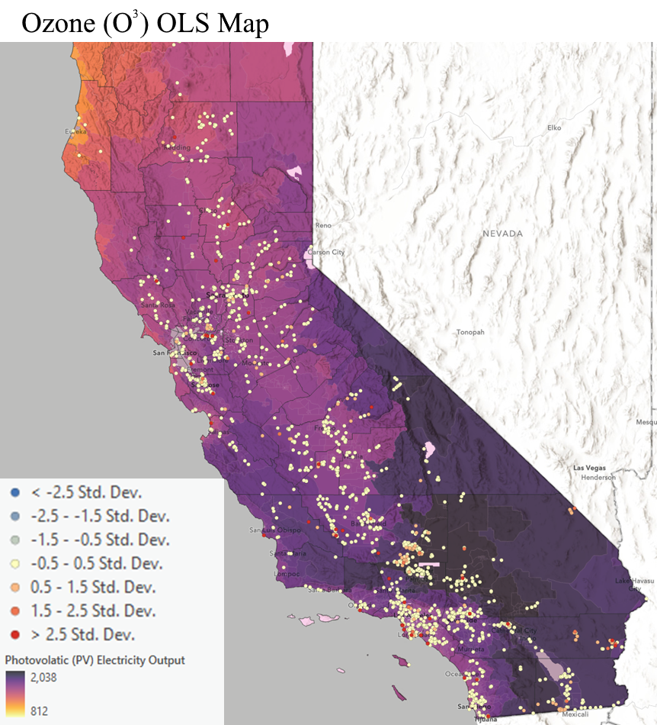

Fig. 1: Ozone (O3) OLS map

Table 1: Summary of ozone OLS results

|  |  |  |  |  |  |  |  |
| --- | --- | --- | --- | --- | --- | --- | --- |
| Variable | Coefficient | Std Error | *t*-Statistic | Probability | Robust SE | Robust *t* | Robust Pr |
| Intercept | 78.624918 | 20.308020 | 3.871619 | 8.000122 | 14.172253 | 5.547806 | 0.000000 |
| AQI | −0.852297 | 0.650139 | −1.310945 | 0.190074 | 0.449594 | −1.895703 | 0.058178 |

From the OLS results for NO2, the coefficient is negative (Fig. 2), supporting our hypothesis that AQI will be inversely related to solar production. The probability for the NO2 results is very significant since it falls below .001 (Table 2).

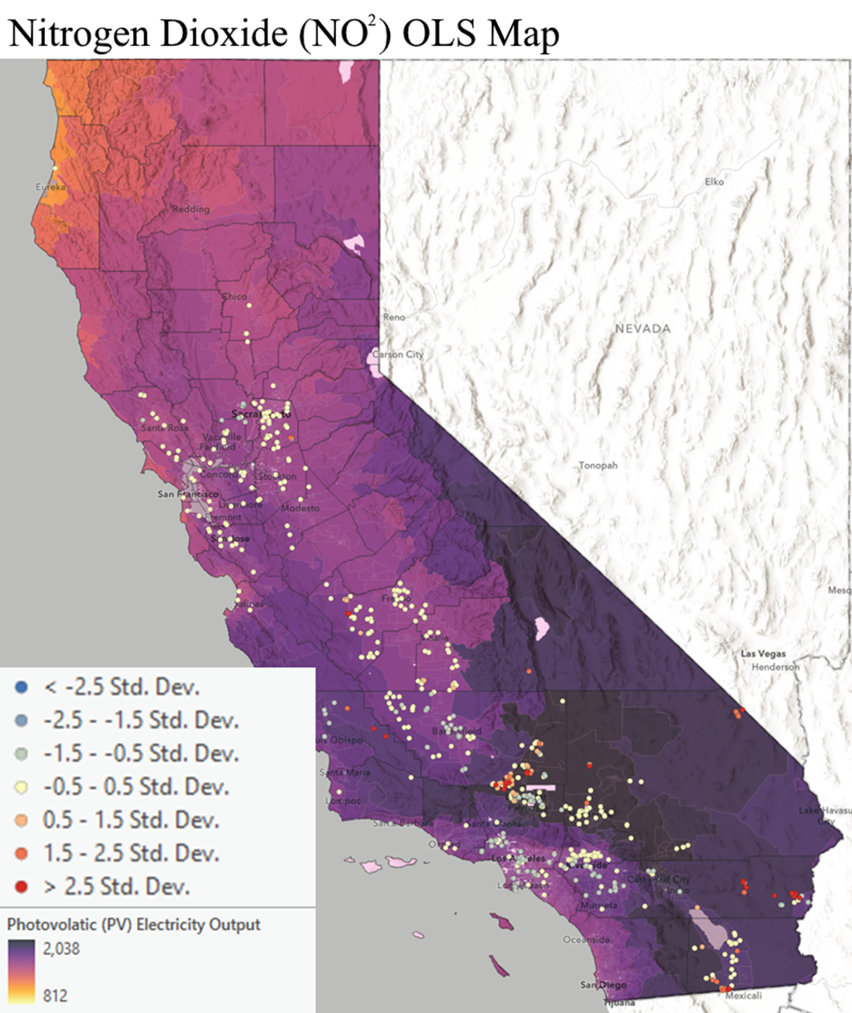

Fig. 2: Nitrogen dioxide (NO2) OLS map

Table 2: Summary of nitrogen dioxide OLS results

|  |  |  |  |  |  |  |  |
| --- | --- | --- | --- | --- | --- | --- | --- |
| Variable | Coefficient | Std Error | *t*-Statistic | Probability | Robust SE | Robust *t* | Robust Pr |
| Intercept | 39.392349 | 4.135786 | 9.524755 | 0.000000 | 4.793422 | 8.218002 | 0.000000 |
| AQI | −1.512156 | 0.375052 | −4.031855 | 0.000069 | 0.334111 | −4.525907 | 0.000009 |

The OLS report for CO shows a positive coefficient (Fig. 3), meaning that AQI and solar production are positively correlated. The probability is greater than .10 (Table 3), so the results are not significant. CO does not appear to support our hypothesis; it is the exact opposite.

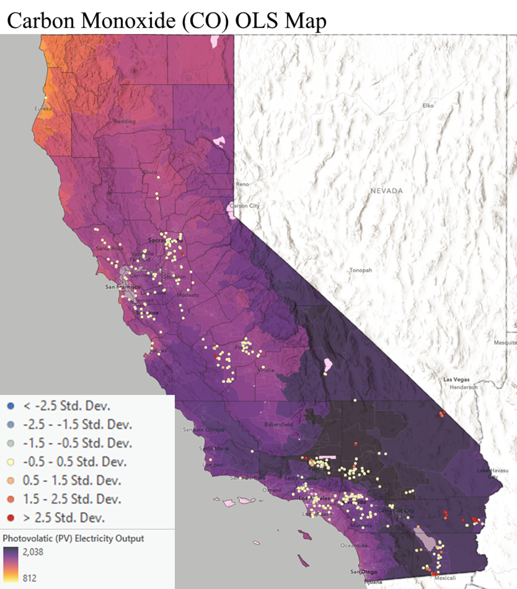

Fig. 3: Carbon monoxide (CO) OLS map

Table 3: Summary of carbon monoxide OLS results

|  |  |  |  |  |  |  |  |
| --- | --- | --- | --- | --- | --- | --- | --- |
| Variable | Coefficient | Std Error | *t*-Statistic | Probability | Robust SE | Robust *t* | Robust Pr |
| Intercept | 17.560886 | 4.933660 | 3.559403 | 0.000420 | 3.26733 | 5.42312 | 0.000000 |
| AQI | 1.148966 | 1.471804 | 0.780651 | 0.435363 | 0.902400 | 1.273234 | 0.203527 |

Finally, SO2 has a negative coefficient (Fig. 4), supporting our hypothesis. However, the probability is greater than .10 (Table 4), meaning it is insignificant.

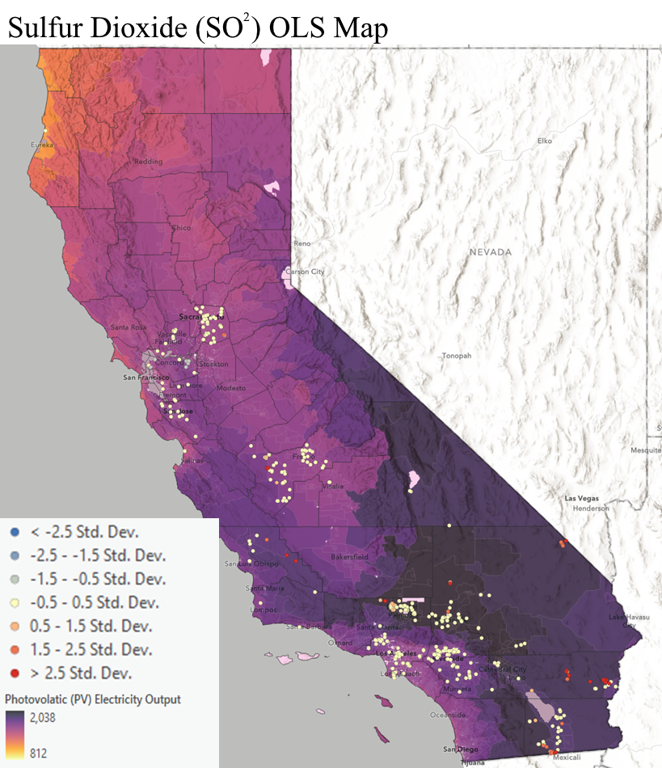

Fig. 4: Sulfur dioxide (NO2) OLS map

Table 4: Summary of sulfur dioxide OLS results

|  |  |  |  |  |  |  |  |
| --- | --- | --- | --- | --- | --- | --- | --- |
| Variable | Coefficient | Std Error | *t*-Statistic | Probability | Robust SE | Robust *t* | Robust Pr |
| Intercept | 27.982504 | 3.675757 | 7.612719 | 0.000000 | 3.692494 | 7.578212 | 0.000000 |
| AQI | −0.509278 | 0.445128 | −1.144115 | 0.253311 | 0.079087 | −6.439479 | 6.000000 |

# 5. Conclusion

In our study, we used ArcGIS Pro to examine the relationship between air quality and solar production, focusing on the influence of key air pollutants—O3, NO2, CO, and SO2. Surprisingly, while a significant negative correlation was observed between NO2 levels and solar output, indicating that higher NO2 concentrations were associated with reduced solar energy generation, the findings for other pollutants were less straightforward. For instance, the unexpected positive correlation between CO levels and solar production challenges conventional assumptions and requires further investigation into underlying factors. Moreover, despite negative correlations found for O3 and SO2, the lack of statistical significance raises questions about the complexity of variables influencing solar energy generation. These insights are crucial for informing policy decisions, technological advancements, and public-awareness campaigns aimed at fostering a sustainable energy future while mitigating the adverse effects of air pollution.

# References

Abel, D. W., Holloway, T., Harkey, M., Meier, P., Ahl, D., Limaye, V. S., & Patz, J. A. (2018). Air-quality-related health impacts from climate change and from adaptation of cooling demand for buildings in the eastern United States: An interdisciplinary modeling study. PLOS Medicine, 15(7) art. e1002599. https://​doi​.org​/10​.1371​/journal​.pmed​.1002599

Bergin M H, Ghoroi C, Dixit D, Schauer J J, and Shindell D T (2017). Large Reductions in Solar Energy Production Due to Dust and Particulate Air Pollution. Environmental Science and Technology Letters, 4(8): 339–344. https://​doi​.org​/10​.1021​/acs​.estlett​.7b00197.

Chandler D L (2018, September 4). This Is How Big an Impact Air Pollution Can Have on Solar Power. World Economic Forum. On the WWW, at https://​www​.weforum​.org​/agenda​/2018​/09​/air​‑pollution​‑can​‑put​‑a​‑dent​‑in​‑solar​‑power.

Chen S, Lu X, Nielsen C P, Geng G, He K, McElroy M B, Wang S, and Hao J (2022). Improved Air Quality in China Can Enhance Solar-Power Performance and Accelerate Carbon-Neutrality Targets. One earth, 5(5): 550–562. https://​doi​.org​/10​.1016​/j​.oneear​.2022​.04​.002.

Isaza A, Kay M, Evans J P, Prasad A, and Bremner S (2023). Air Quality Impacts on Rooftop Photovoltaic Energy Production During the 2019–2020 Australian Bushfires Season. Solar Energy, 257: 240–248. https://​doi​.org​/10​.1016​/j​.solener​.2023​.04​.014.

Jato-Espino D, Castillo-Lopez E, Rodriguez-Hernandez J, and Ballester-Muñoz F (2018). Air Quality Modeling in Catalonia from a Combination of Solar Radiation, Surface Reflectance and Elevation. Science of the Total Environment, 624: 189–200. https://​doi​.org​/10​.1016​/j​.scitotenv​.2017​.12​.139.

Juliano T W, Jiménez P A, Kosović B, Eidhammer T, Thompson G, Berg L K, Fast J, Motley A, and Polidori A (2022). Smoke from 2020 United States Wildfires Responsible for Substantial Solar Energy Forecast Errors. Environmental Research Letters, 17(3): art. 034010. https://​doi​.org​/10​.1088​/1748​‑9326​/ac5143.

Khan A, Ali Y, and Pamucar D (2023). Solar PV Power Plant Site Selection Using a GIS-Based Non-linear Multi-criteria Optimization Technique. Environmental Science and Pollution Research, 30(20): 57378–57397. https://​doi​.org​/10​.1007​/s11356​‑023​‑26540​‑1.

Mandal D K, Bose S, Biswas N, Manna N K, Cuce E, and Benim A C (2024, March 12). Solar Chimney Power Plants for Sustainable Air Quality Management Integrating Photocatalysis and Particulate Filtration: A Comprehensive Review. Sustainability, 16(6): art. 2334. https://​doi​.org​/10​.3390​/su16062334.

Millstein D, Wiser R, Bolinger M, and Barbose G (2017, August 14). The Climate and Air-Quality Benefits of Wind and Solar Power in the United States. Nature News. On the WWW, at https://​www​.nature​.com​/articles​/nenergy2017134.

Milton D K (2020). A Rosetta Stone for Understanding Infectious Drops and Aerosols. Journal of the Pediatric Infectious Diseases Society, 9(4): 413–415. https://​doi​.org​/10​.1093​/jpids​/piaa079.

Son J, Jeong S, Park H, and Park C-E (2020). The Effect of Particulate Matter on Solar Photovoltaic Power Generation over the Republic of Korea. Environmental Research Letters, 15(8): art. 84004. http://​doi​.org​/10​.1088​/1748​‑9326​/ab905b​.potent.

Song Z, Liu J, and Yang H (2021). Air Pollution and Soiling Implications for Solar Photovoltaic Power Generation: A Comprehensive Review. Applied Energy, 298, art. 117247. https://​doi​.org​/10​.1016​/j​.apenergy​.2021​.117247.

Weng Q, and Yang S (2006). Urban Air Pollution Patterns, Land Use, and Thermal Landscape: An Examination of the Linkage Using GIS. Environmental Monitoring and Assessment, 117(1–3): 463–489. https://​doi​.org​/10​.1007​/s10661​‑006​‑0888​‑9.

Zhang C, Shen C, Yang Q, Wei S, Lv G, and Sun C (2020). An Investigation on the Attenuation Effect of Air Pollution on Regional Solar Radiation. Renewable Energy, 161: 570–578. https://​doi​.org​/10​.1016​/j​.renene​.2020​.07​.146.

Zhou Z, Lin A, Wang L, Qin W, Zhao L, Sun S, Zhong Y, He L, and Chen F (2021). Estimation of the Losses in Potential Concentrated Solar Thermal Power Electricity Production Due to Air Pollution in China. Science of The Total Environment, 784: art. 147214. https://​doi​.org​/10​.1016​/j​.scitotenv​.2021​.147214.